Review Article:
CHALLENGE OF ENVIRONMENTAL TOXICOLOGY IN REFORMATION ERA

Titiek Berniyanti
Department of Dental Public Health
Airlangga University School of Dentistry

ABSTRACT

Industrial development has provided significant impact on the environment due to inappropriate arrangement and processing of industrial waste. The burden of the environment becomes heavier and results in environmental imbalance. One of the problems is the exposure of chemical substances, which is increasingly used for industry. Therefore, controlling effort is needed to prevent more severe damage resulting from these substances. In this relation, environmental toxicology, a science on the adverse effect of environmentally-distributed chemical substances on biological system, is beneficial to predict outcomes related with toxic hazards of chemical substances in human beings and environment. This science has a wide scope, either in medicine, food industries, farming, or chemical industries. It is also divided into several subdisciplines, such as forensic toxicology and occupational toxicology. This discipline should be able to find solution for appropriately controlling the exposure of chemical substances. Since it is still recognized by a small fraction of the society, its socialization becomes imperative. Toxicology should be introduced to students ranging from those at elementary level of education to those who go to universities through their curriculum of education.

Keywords: environment, environmental toxicology, industrial development, chemical substances,
education on environmental toxicology

Correspondence: Titiek Berniyanti, Department of Dental Public Health, Airlangga University School of Dentistry,
Jl Prof Dr Moestopo 47, Surabaya 50131, phone 62-31-5030255.

INTRODUCTION

The development of industrial sector, particularly large industries, to fulfill the need of modern society by the application of economic principles has provided significant impact on the environment. In addition, we are bombarded by chemicals in our cosmetics, fragrances and cleaning fluids, spray our homes with insecticides and use fungicides on our household plants. We have toxic bombs under our kitchen sinks, spray our lawns with toxic pesticides and herbicides and then send our children out to play. We cook our food in plastic, releasing xenobiotic estrogens and carcinogens like diethyl-hexyl adepate and then store or cook the leftovers in aluminum foil. Microwave safe only means the container will not be damaged but does not mean the food would be safe. Our drinking water is “purified” by chlorination to kill the bacteria and then aluminum is added to precipitate out an aluminum chloride sludge. In most communities there is no monitoring of aluminum levels in drinking water. Some communities allow more chlorine in their drinking water than in their pools. Hormones, pharmaceuticals and thousands of chemicals have entered our water supply and are not recognized or filtered out of drinking water. Radon, many of the common pesticides and other contaminants are not detected or do not need to be reported to the consumers (Freedenfeld 2007).

The impact on man and the environment may result from inappropriate arrangement and processing of industrial, agriculture, the military, medicine, and dentistry waste. The development of industrial sector, agriculture, the military, medicine, and dentistry involves the use of a high amount of chemical substances, resulting in significant increase of its commercial production. Due to the increase of the amount and type of chemical substances, particularly for raw materials, the burden of the environment becomes heavier. This impedes the interaction between living beings and environment due to environmental imbalance. The implication of chemical industry production process is the direct contact with various levels of community who are involved in its production process, handling, using, and consumption or abuse. Permanent exposure of chemical substances may occur through the environment. This occurs slowly, but provides significant effects. Not all industrial waste processing systems have met the appropriate procedure. Not infrequently the factories just dump their waste to the body of the river without taking any waste processing.
Water pollution is one implication of erroneous industrial waste processing. The waste is directly dumped into water body without appropriate waste processing. Although there is treatment from human, chemical interactions among environmental polluting substances may occur and enable the emergence of toxins, for example, the alteration of anorganic mercury compound into organic compound by microorganisms, particularly methyl and dimethyl mercury, which are highly hazardous for human health and the life of water organisms. Controlling effort should be considered to prevent more severe damage since members of the community who are exposed to chemical substances are increasing in number along with the development of modern society with advanced technology.

In this context, the involvement of toxicologists is necessary, either in industrial or environmental field, to provide contribution in solving the problem. Environmental toxicology, defined as a science on the adverse effect of environmentally-distributed chemical substances on biological system, is beneficial in predicting the results related with toxic hazards of chemical substances in human beings and their environment. Not infrequently, the existing exposure is highly mild so that it is acutely not hazardous and clinically unapparent, but it may provide adverse effects in longer term.

Undeniably, industrialization has induced complicated new problems. However, emotional rejection to industrialization by the majority of the community only leads to new threat with other difficulties. Industrial production that is regarded as the material of welfare and the basis of prosperity should be proceeded, since it is the basis to improve adequate living standard for million of people in the world. Environmental protection is indeed absolutely needed. However, actions to oppose industrial activities only damages human welfare and health. Environmental protection should not be presented as emotional and confrontative efforts. It instead should be attempted in the framework of welfare by developing scientific discourse that provides motivation for scientists to improve their qualification, particularly in the field of toxicology, in overcoming the problems.

TOXICOLOGY AND ENVIRONMENTAL TOXICOLOGY

The possible environmental impact caused by certain routines either from industrial activities or medical activities (medical or dental practice) has attracted attention among regulators. In general, the amount of waste generated in dental offices is considered to be relatively small compared with that of other healthcare facilities, such as hospitals, and industry. In most countries, the characteristics of the dental clinic waste, however, cause it to be addressed in laws and regulations covering waste disposal. All hazardous waste in dental offices must thus be handled according to national regulations, and the dental team should be adequately educated to collect and handle the wastes according to the current regulations. Hazardous wastes generated by the handling of dental filling materials are generally classified chemical wastes.

Chemical wastes from the dental profession can be subclassified as liquids and solids. Among the liquids, mercury contaminated waste water and disposal of photographic solutions are of major environmental concern. Some metals, including chromium, nickel, arsenic, cadmium, and cobalt, have long been recognized too as human and/or animal carcinogens. Their carcinogenic potentials depend largely on factors like oxidation state and solubility. Thus, exposure to chromium(VI) is strongly associated to human lung cancer, while chromium(III) is largely inactive. This discrepancy is related to differences in bioavailability; while chromium(III) is unable to cross the cell membrane, chromium(VI) is readily taken up by anion transporter followed by intracellular reduction to chromium(III) (Arenholt-Bindslev 1998)

Toxic effects are highly varied in its nature, target organ as well as action mechanism. However, all works due to the presence of biochemical interactions between toxicants (and/or their metabolites) with certain receptor structure in the body. Science that is studying the effect of toxins on human biological systems called as Toxicology. The scope of toxicology in medicine, for diagnostic, preventive, and therapeutic purposes, in food industries, as direct and indirect addition, in farming, as pesticide, growth regulator substance, artificial pollen, and additional food for animals, and in chemical industries, as solvent, component, and materials for plastics and other types of chemical substances, also used to investigate the effect of metal (such as that in mining and melting sites), crude oil products, paper and pulp, poisonous plants, and animal toxins on health.

Due to the width of the scope of toxicology and the need to meet several targets, toxicology is divided into several subdisciplines, such as Forensic toxicology that is studies the medicolegal aspects of chemical substances that have hazardous effect on human or animals, so that this study can be used to assist searching and explaining the cause of death in criminal case investigation. Industrial/occupational toxicology that is a science that studies the mechanism and toxic effects of environment pollutants on human biological system. The source of pollutant, its transport, degradation and bioconcentration in the environment, as well as its effect on human are discussed in this study. Environmental Toxicology that is studies the exposure of various toxicants through air, water, and food, which are presenting as food additive, pesticide, and pollutant, may experience exposition phase that comprises early absorption process and toxin fraction into the form of active substances. Subsequently, the substance will experience toxocyrtetic phase, in which the substance is distributed to various organs of the body through blood. Some will be pooled within fat depository, subjected to excretion and biological transformation (see Figure 1) (Berniyanti 2000)

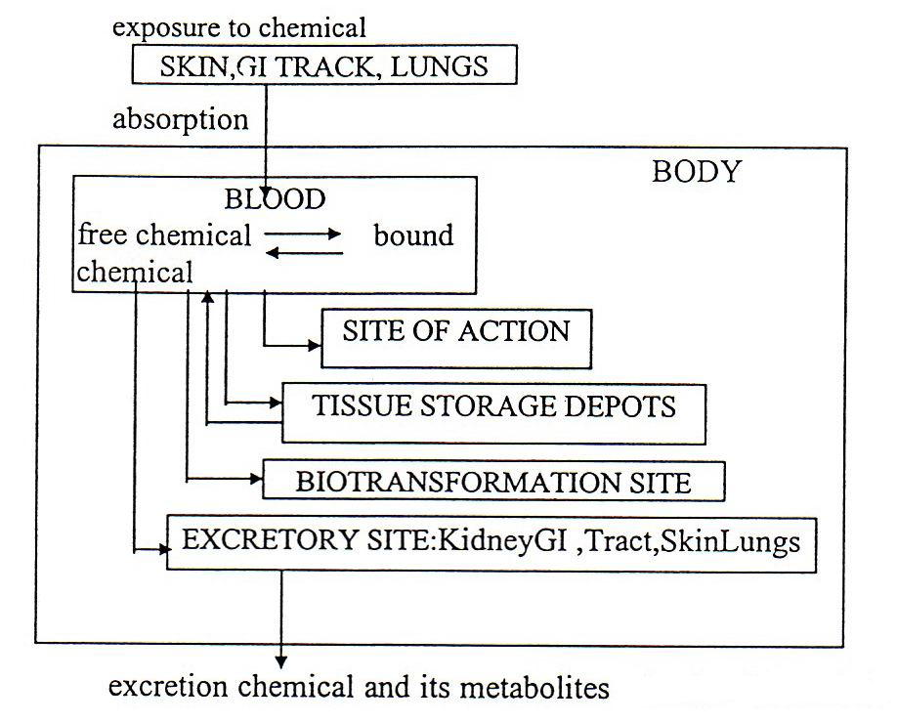

Figure 1. Metabolic pathway for foreign chemical
(Vander 1985).

Fat tissue can be regarded as important depository site for fat-soluble substances, such as DDT, diecdrin, and biphenyl polychlorine (PCB). These substances are deposited in fat tissue with simple solvent in neutral fat. There is a possibility that plasma level of substance deposited in the fat will increase sharply due to rapid fat mobilization during hunger. Fatty acid conjugation with toxicants, such as DDT, may also serve as chemical accumulation mechanism in lipid-containing tissue and in body cells (Friberg 1972).

Metabolism process or biotransformation and toxic substances are the main determining factor in the toxicability of related substances. Material, such as mercury has a wide variety of applications in industry, agriculture, the military, medicine, and dentistry. It has been estimated that 3–4% is used in dentistry. In general, the amount of waste generated in dental offices is considered to be relatively small compared with that of other healthcare facilities, such as hospitals, and industry. According to WHO estimates, around 3,000 tons of mercury are emitted into the atmosphere yearly as a result of human activities, such as processing of minerals and ores, and combustion of fossil fuels. Even though mercury may affect a number of basic biological mechanisms, the uptake and toxicokinetics of mercury in its different chemical forms may vary considerably in different species Environmental mercury is accumulated in food chains, particularly in the aquatic environment, where a high degree of biomagnification occurs in the food chain of predatory species. Concentration factors exceeding 100,000 from the algae level and upwards have been reported (Clarkson et al. 1972).

In areas with polluted water, levels of methylmercury in living organisms, e.g., fish, will increase with a tendency to increasing levels with increasing size and age of fish (Arenholt-Bindslev 1998). Through this process the toxicant will increase or decrease its toxicability since in this process every incoming substances or materials will be processed and changed into more uncomplicated forms, as simple molecules or compound. In this case, in the process of formation changing, which presents as a sequence of chemical events, a toxicant may be bound with other toxicants, leading to the augmentation of its existing toxicability or, on the contrary, may be bound with other antagonistic toxicant, leading to the decrease or neutralization of its toxicability.

In this biotransformation process, enzyme usually holds a very important role as a stimulator to enhance or facilitate the process. The function of an enzyme is to regulate and facilitate the metabolism in the body. In carrying out it works, enzymes often require metals or vitamin or combination of both as co-factor or activator, and these metal ions are also called as an active center of an enzyme cluster. However, enzymes with metal ions as active cluster, are often unstable, in which the metal ions are replaceable with other metals that also enters the body. Zn and Fe deficiency often causes the incoming of Pb to replace the function of metal ions from enzyme cluster and inhibits the working capability of related metal ions. Certain enzymes also contain sulfhydryl (-SH) cluster as its active center. The workability of these enzyme groups is the easiest to be inhibited. Such condition occurs because the sulfhydryl contained will be easily bound with heavy metal ions entering the body and result in high reduction or even absence of the enzyme's workability. After absorption and distribution in the body, toxicant can be excreted quickly or slowly in its original form, either as metabolite or conjugate. The major excretion pathway is urine, but liver and lungs, kidney and brain are also important excretion organs for certain chemical substances.The subsequent phase is the toxodynamic phase, including interactoin between toxon and receptors within organs and the formation of toxic effects in the body, such as chemical irritation, degenerative, hypersensitive, fibrotic, psychotoxic, habituation, dehydration/homeostatic effects, and the most severe is the teratogenic as well as carcinogenic effects (Palar 1994).

CHALLENGE FOR ENVIRONMENTAL TOXICOLOGY IN REFORMATION ERA

Along with the development of industries, the field of environmental toxicology faces a remarkable challenge. Roughly 25 % of U.S. workers risk some illness from routine exposure to one or more toxic compounds. According of the National Academy of Sciences, there is no information on the possible toxic effect of 80% of the roughly 50.000 Industrial chemicals used in the United States. 7 The situation is much worse in most other countries, according to Wahli record, 1999, there is water pollution much even worse in Surabaya river, that effect the quality of clean water drop from B to C tipe. The Surabaya river is one of the raw material for drinking water. The pollution happenened as a result of waste product from industtrial around the river. The effect of what is called analin tumor found by Rehn (1895) in the bladder of three analin factory workers was firstly found 40 years later, after studies in experimental animals were carried out. This indicated that the effect of exposure in a short time limit will not be observable. Scientific studies are needed to learn the effect of toxic exposure (Amsyari 1989). At the end of 1950, thalydomide was commonly used as sedative. This drug had a very low acute toxicity so that it meets the requirement of toxicity test protocol prevailing at that time. However, a type of very rare innate abnormality (focomelia, the absence of body limbs) emerged in several mothers who consumed this drug during the first trimester of their pregnancy (Lenz & Knapp 1962). This tragedy triggered various studies in the field of teratology, a particular field in toxicology. Several studies in this field have shown that the modification of toxic effect is an important factor in the effort to prevent intoxication that is hazardous to the life of mankind. Toxic effect may change due to various causes such as absorption, chemical substances distribution and excretion, biotransformation reduction and the change of receptor sensitiveness on target organs. In the effort to design toxicology research protocol, these factors are important to understand.

The challenge faced by environmental toxicology today is to find solution for appropriately controlling the exposure of chemical substances. This is possible if the toxicologists are able to identify various exposure indicators and signs of its early and reversible effects on health. In industrial development, industrial waste is produced in huge amount, providing effect on the environment. Materials identified as industrial/factory waste and environment pollutant are Daily meals, Food factory, Textile, Tanning, Paper,Chemical, Petrochemical, Culinary,Petroleum industry, Industry, Metallurgy, Laundry, and Farming.

Materials resulting from toxicant of industrial waste are classified into 6 classes: 1. Physical effect: such as suspended matters that cause turbidity in water, cooling water waste may increase the temperature and oil layer may inhibit water reoxygenation. 2. Oxidation effect: resulting from bacterial activity or chemical oxidation from organic and anorganic substances that reduced soluble oxygen level. 3. The effect of toxic compound or chemical substances, resulting in direct or cumulative psychological change in plants, animal, or human.
4. Chemical nutrition effect, resulting in high nitrate and phosphate concentration. 5. Pathogenic effects caused by microorganisms, in which bacteria and viruses emerge in sufficient number to impose threat against human's health. 6. Radionuclide effect, resulting from the accumulation of radioactive compound in organism diet that results in changes in human body. 7. The development of biotechnology that produces new food resources beyond the conventional ones (conventional crops).

ENVIRONMENTAL TOXICOLOGY SOCIALIZATION FOR PUBLIC HEALTH

Recently, environmental toxicology is only recognized by a small fraction of the society, those who are involved and engaged in medicine, public health, and pharmacy, and some fields related to chemistry. Such limited knowledge has effect on public health in general. Minimal public knowledge on toxicology worsens the existing condition in the society. Limited (superficial) knowledge of toxicology among individuals or community in medicine, public health, and other fields as well, is inseparable from existing teaching curriculum prevailing in the educational system of those strata. In our country, rapid development of knowledge during globalization era is not accompanied with the development of education system, at least justification for the curriculum should follow the change and development of knowledge.

Current toxicology becomes a need for almost all of the society. This is closely related with the effects produced by technological changes and development touching some parts of the society, particularly the industrial community. Therefore, socialization of this knowledge is imperative, either in simple form presenting as the lesson of environmental knowledge embedded in the formal educational curriculum, or through non-formal education system, such as scientific speeches in the community, courses, promotions and training with the emphasize on the danger of environmental toxicants.

During the current era of development, an openness of attitude is needed to accept various changes that lead to the improvement of public welfare. The society needs reformation in various fields. The field of health care and education also need a change that is able to accommodate the whole basic needs of the people. Problems related to public health and basic knowledge level should be put into priority.

Formally, the knowledge of environmental toxicology is only possible to be delivered in certain education levels and also for certain scientific fields. However, along with the wind of change and basic needs of health care and education, this study should have been given to the most basic educational level. Cases of intoxication among elementary school children who received additional food should become a reference to give simple explanation of the effect of the use of chemical substance (pesticide) and unhealthy food process. This can be enabled by adding materials to local content in areas with particular characteristics, such as industrial area. At the level of elementary education, for example, there has been a material on environmental science, although in a simple scope of the concept of the science. A little bit of knowledge on environmental toxicology can be added by providing practical and clear examples, such as how to choose healthy food, without dye, and why meatball is pliable and delicious. At the level of junior high school, the subject can be more widely developed through the class of Natural Sciences and for senior high school toxicology can be given through environmental sciences as well as certain other materials in chemistry, physics, and biology. Another problem is whether the teachers who teach in these levels of education also have knowledge on environmental toxicology. Short-term solution for this problem is by providing upgrading or short courses, while the long-term solution is by combining this material or study into the curriculum of teaching education. In higher education institutions that provide studies other than health or medical sciences, the material can be given as an optional subject, while in those providing health or medical sciences the curriculum should be reviewed and the materials should be deepened and enriched as well.

REFERENCES

Amsyari, F 1989, Radiasi Dosis Rendah dan Pengaruhnya pada Kesehatan Masyarakat, Airlangga University Press, Surabaya
Amsyari, F 1996, Membangun Lingkungan Sehat, Airlangga University Press, Surabaya.
Arenholt-Bindslev, D 1998, ‘Environmental aspects of dental filling materials’, Eur J Oral Sci, vol. 106, pp. 713–720.
Berniyanti, T 2000, ‘Dampak penggunaan merkuri pada kesehatan masyarakat’, Majalah Kedokteran Gigi, Vol. 33. Hal: 1-14
Clarkson et al. 1972, 'An outbrake of methylmercury poisoning due to consumption of contaminated grain', Fed Proc, vol. 35, pp. 2394-2399.
Freedenfeld, SW 2007, Understanding Environmental Toxicity, Stockton, NJ pp. 8-13.
Friberg, 1972, Mercury in the Environment, CRC Press, Ohio.Hal 22-30
Hoar & Monie, 1988, 'Comparative development of specific organ systems', in CA Kimmel & J Buelke-Sam (eds), Development of Toxicology, Raven Press, New York, pp. 13-33.
Lenz & Knapp 1962, 'Thalidomide embryopathy', Arch Environ Health, vol. 5 pp. 100-105.
Lu, FC 1991, Basic Toxicology: Fundamentals, Target Organ and Risk Assessment, Hemisphere Publishing Corporation
Miller, T 1996, Living in the environment, Wandworth Publishing Company, A Division of International Thompson Publishing Inc., pp. 403-427.
Palar, H 1994, Pencemaran & Toksikologi Logam Berat, PT Rineka Cipta, Jakarta, pp. 24-25.
Vander, AJ et al. 1985, Human Physiology, McGraw-Hill Book Company, New York.

